

**AWS Project**

Team Name:Weekenders

Members:

1. Monika C R(r_monika_c@lilly.com)

2. Rachana P M(p_m_rachana@lilly.co,)

3. Mahaan Krishna (krishna_mahaan@lilly.com)

4. Deeksha Hegde (hegde_deeksha@lilly.com)

Creating vpc1

Created 4 subnets in VPC1

Created VPC2

Created 2 private subnets in VPC2

Created Two Route tables for VPC1 (One for private subnets ,one for public subnets)

Creatin Internet gateway and attach to VPC1

Added internet gateway to public route table

Created NAT gateway for one of the private subnets of VPC1

Addeed NAT gatewauy to private route table of VPC1

Created 4 EC2 instances in VPC1(2 EC2 instances using private subnets and 2 EC2 instances using public subnets)

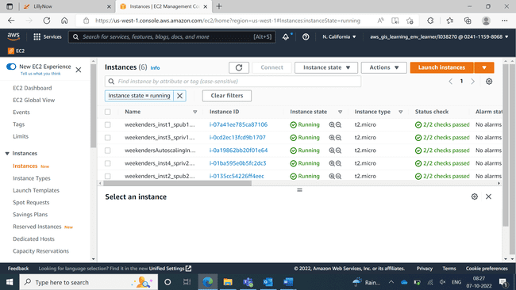

Installing apache in one of the public ec2 instances

Checking in browser

Created images of public EC2 instances

Created templates of pub EC2 instances

After autoscaling using public EC2 instances one instance has been created

killing the process

Created database

Created S3 bucket

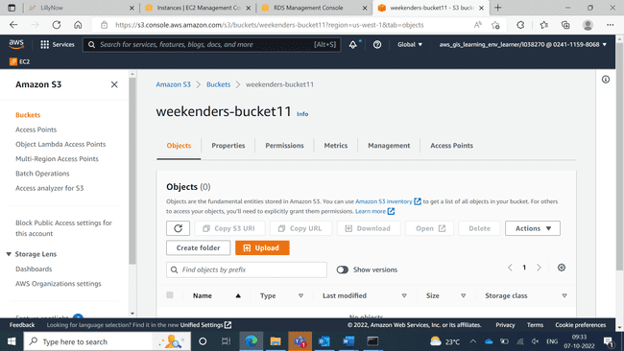

Installed mariadb in private instance

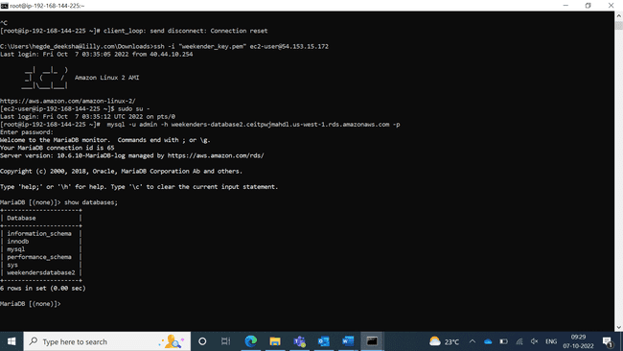

Created lambda function

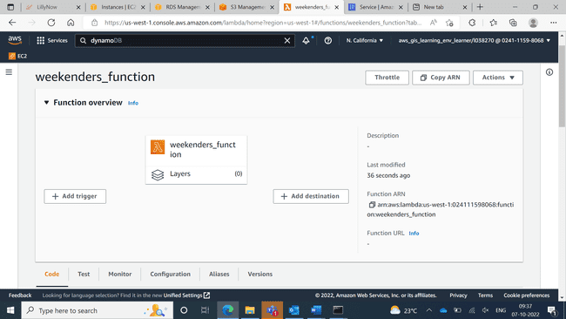

Created DynamoDB table

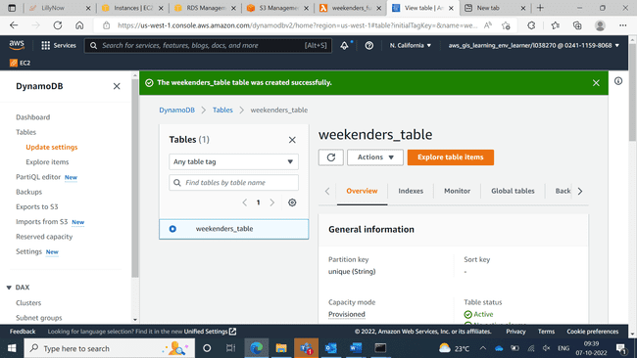

Added trigger in lambda function

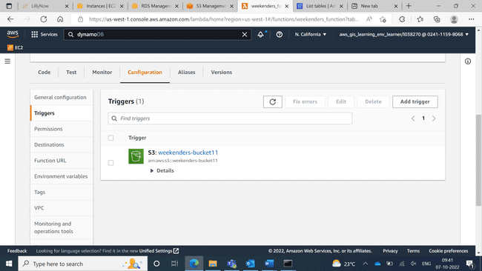

Code in lambda function

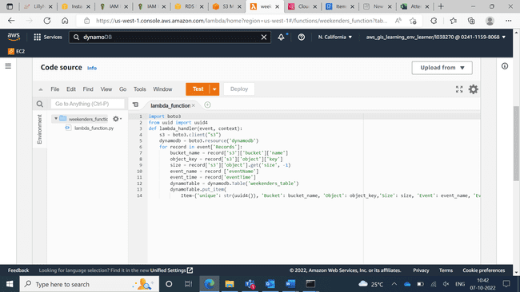

Upload objects to bucket

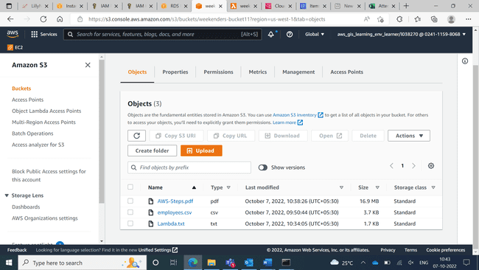

Objects are uploading into DynamoDB table

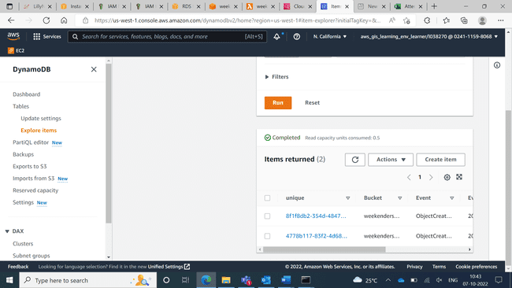

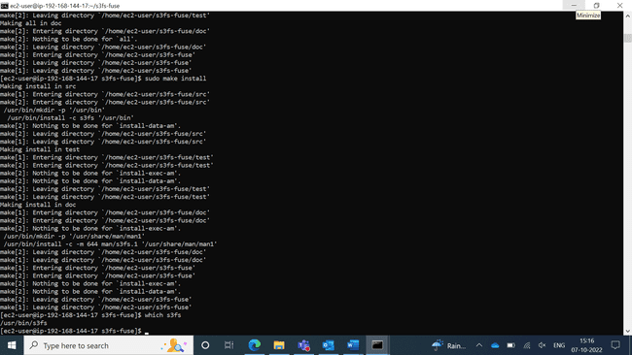

Mounted s3 bucket

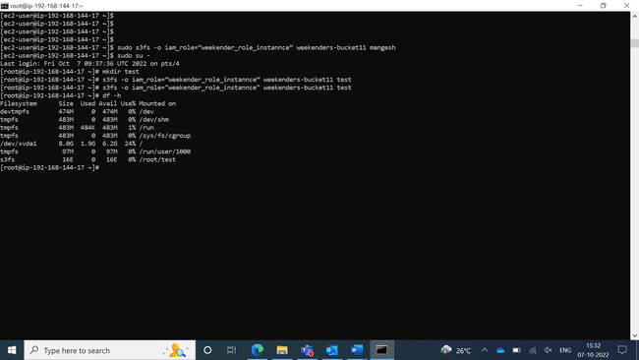

Created route table for vpc2

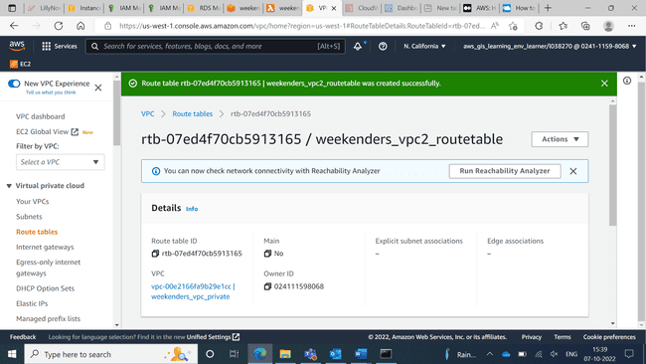

Created 2 EC2-instances using VPC2 and subnets

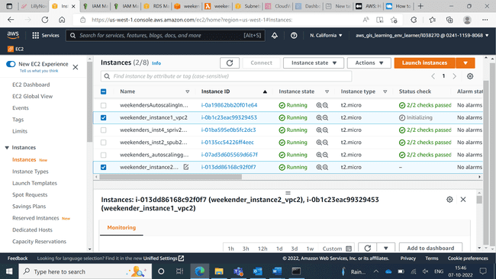

Done peering connection of 2 VPCs 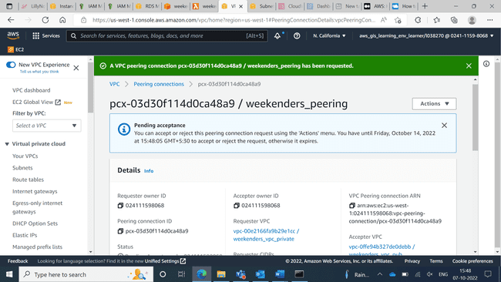

Created EFS

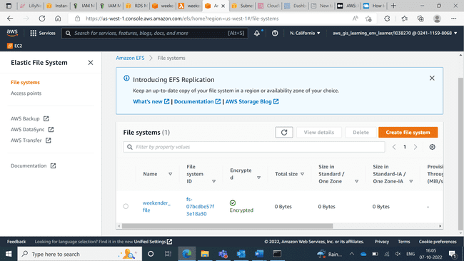

Mounted EFS both instances

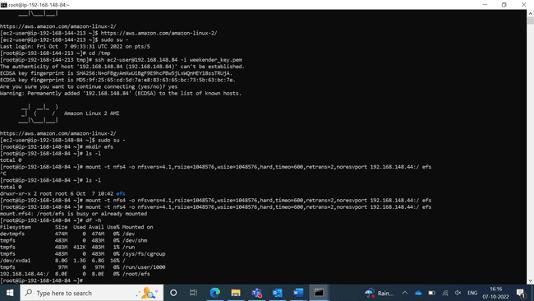

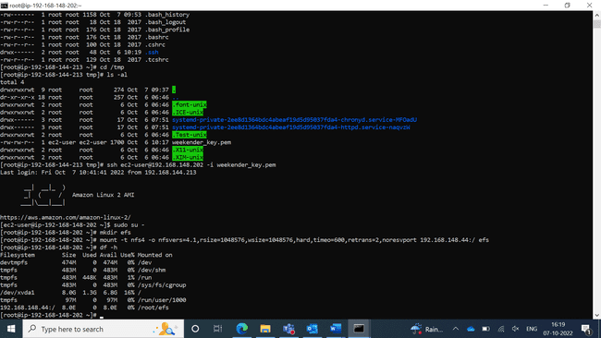

Created new bucket

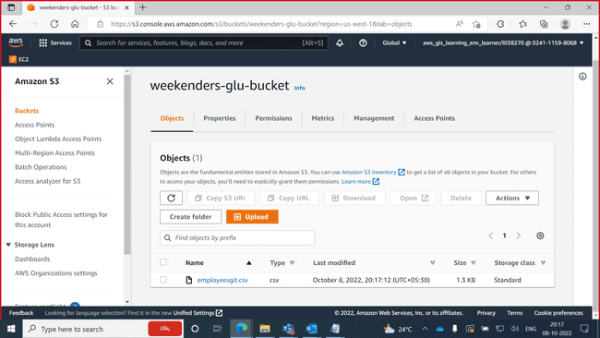

Database

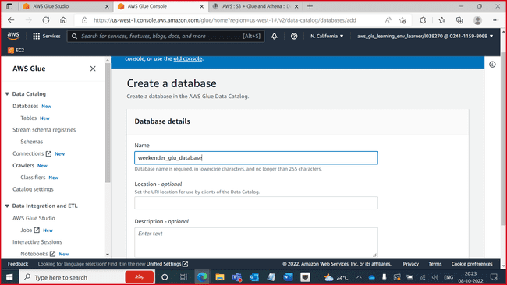

Creating crawler

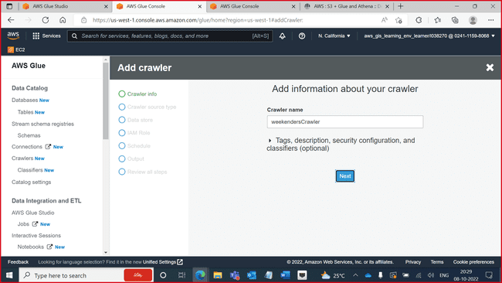

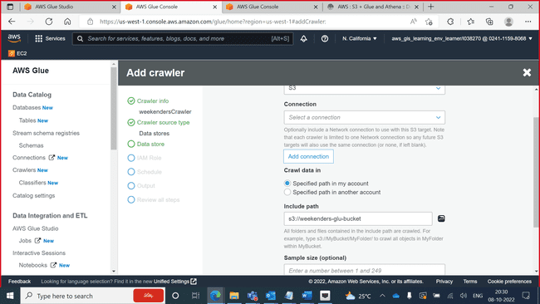

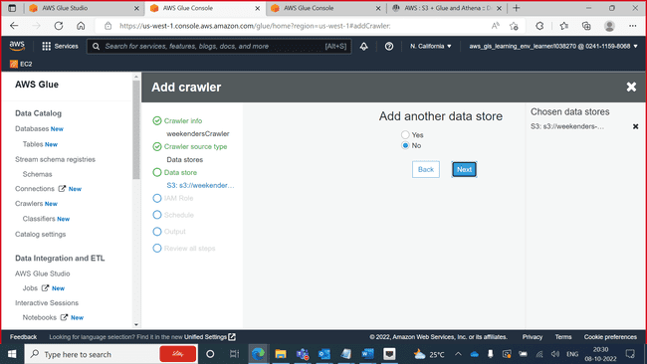

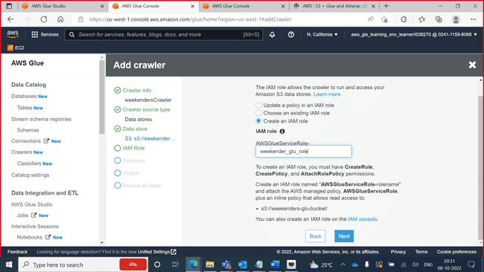

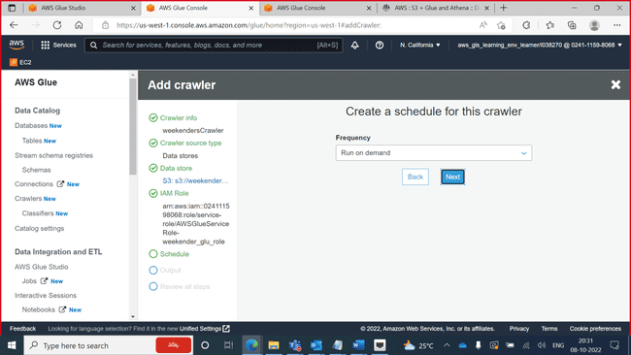

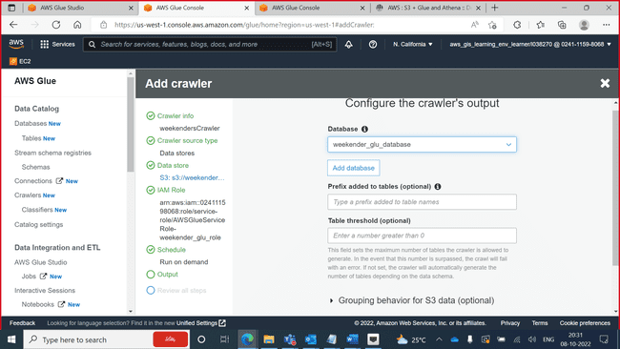

Created Crawler

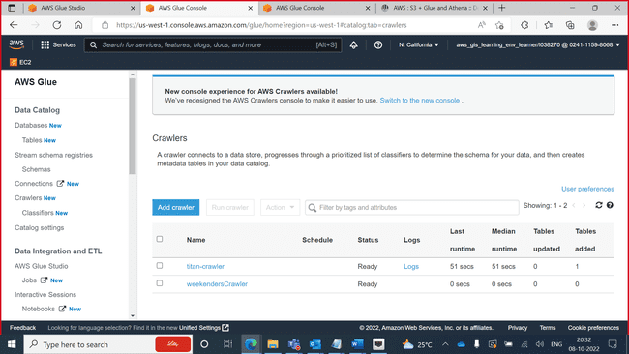

Running Crawler

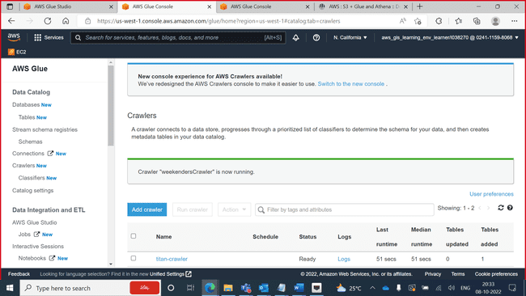

Starting Crawler

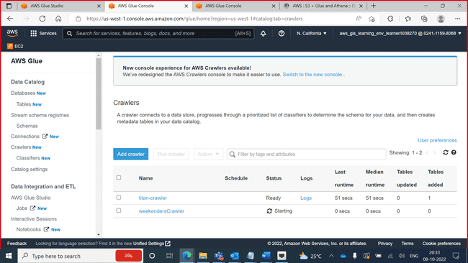

Stopping Crawler

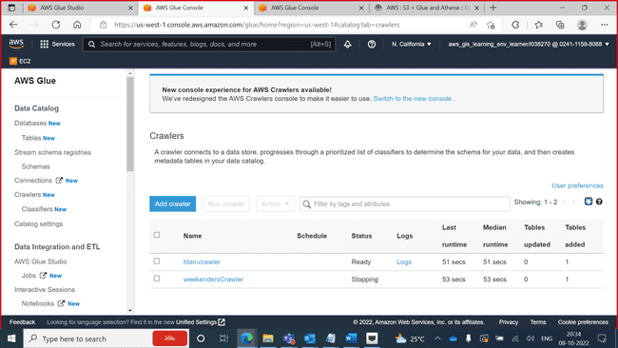

Can see the tables now

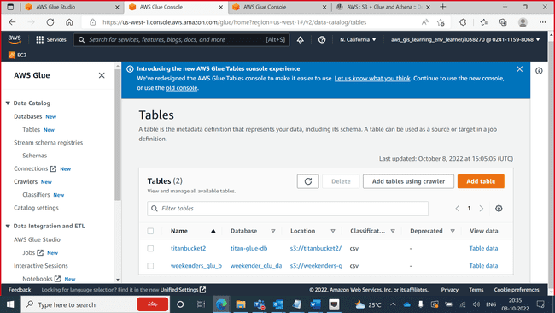

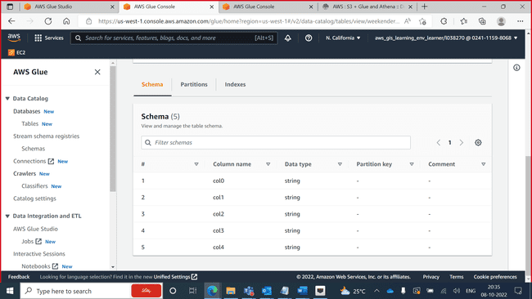

Updating Schema

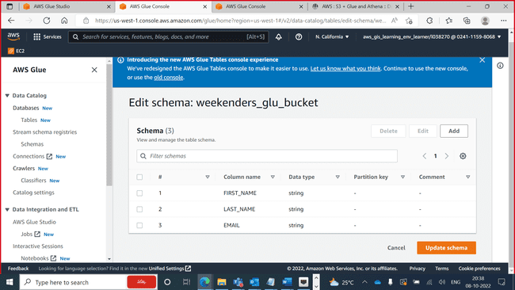

Schema updated

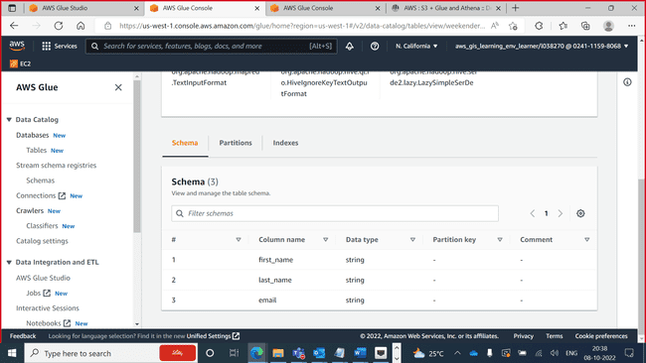

Seeing tables in glue

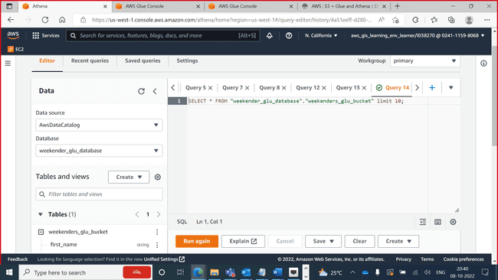

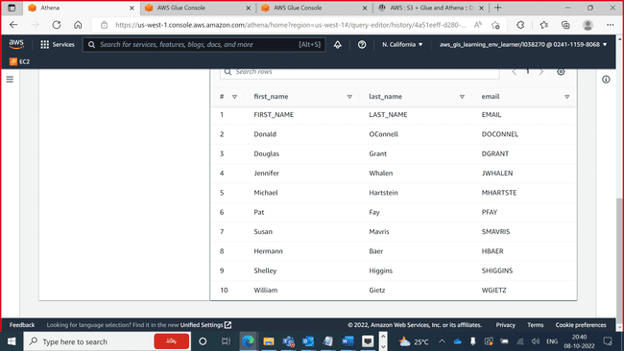

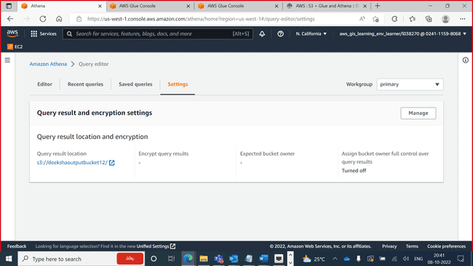

Created new database

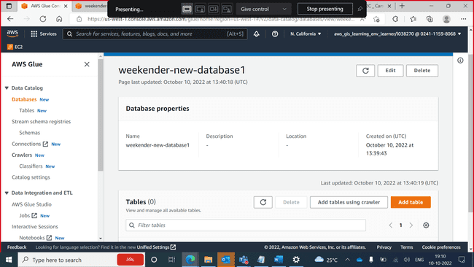

Created new crawler

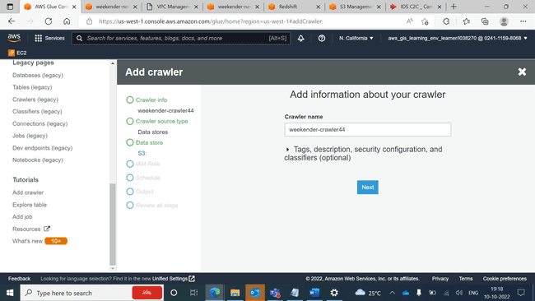

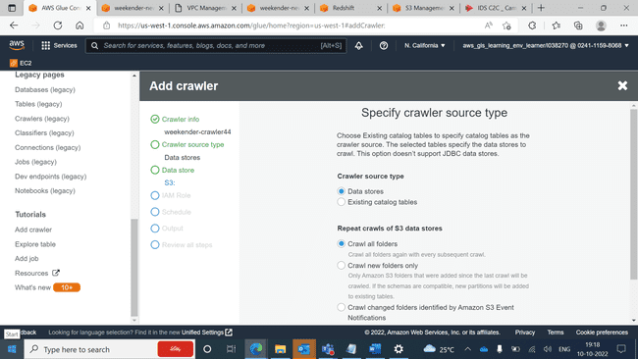

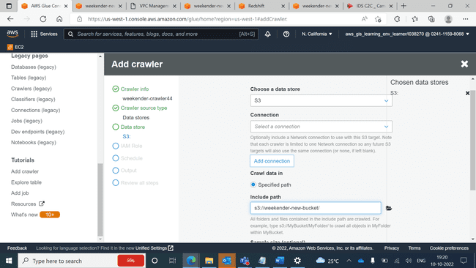

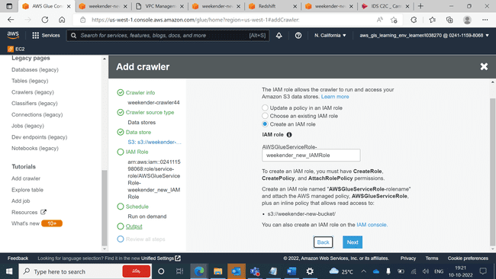

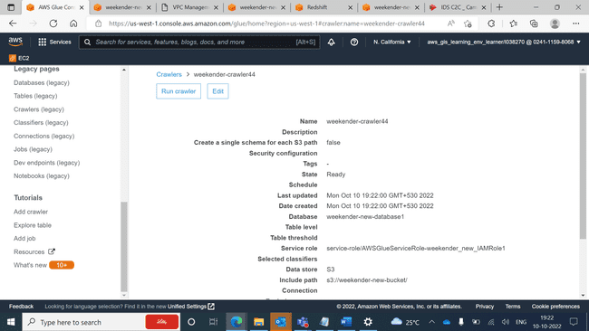

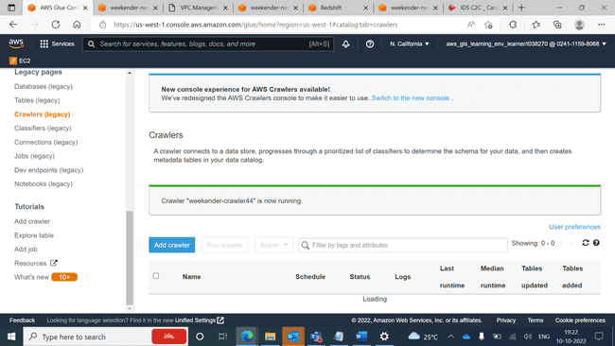

Now can see the tables

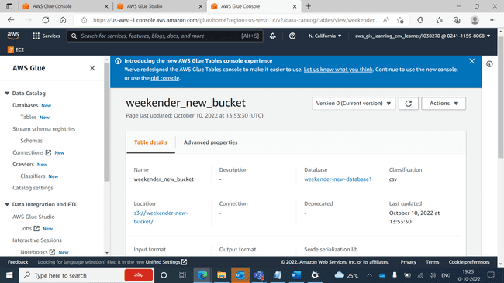

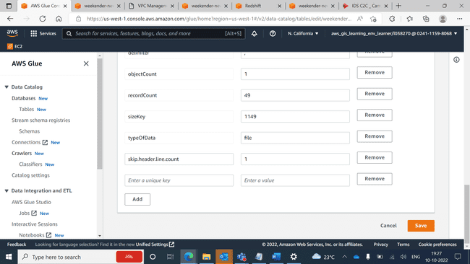

Endpoint created

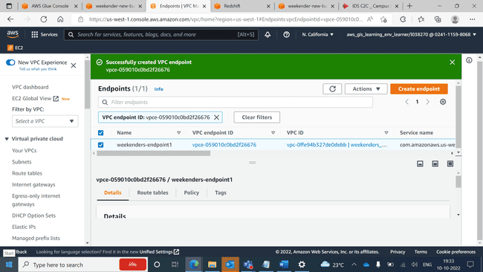

Creating cluster subnet group

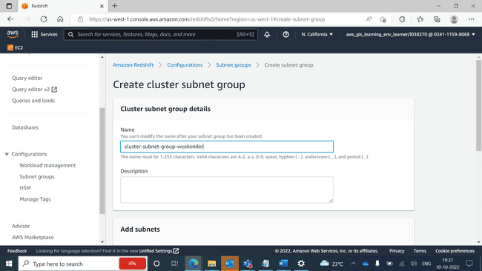

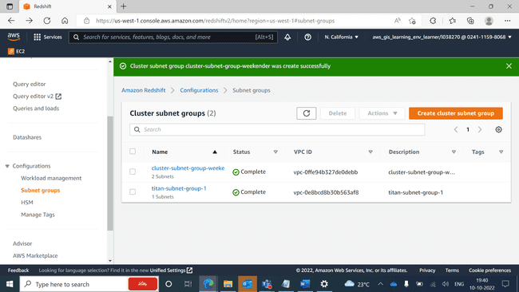

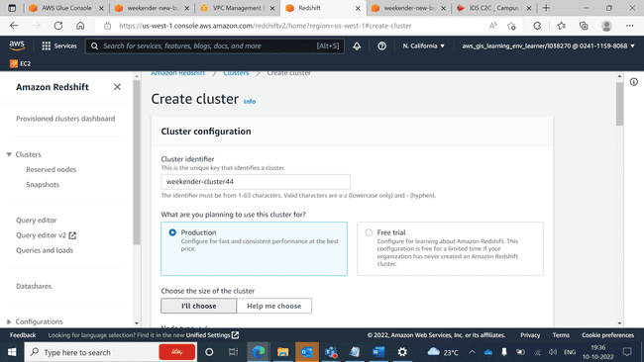

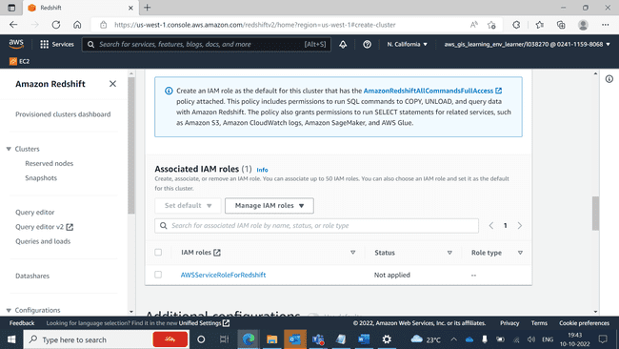

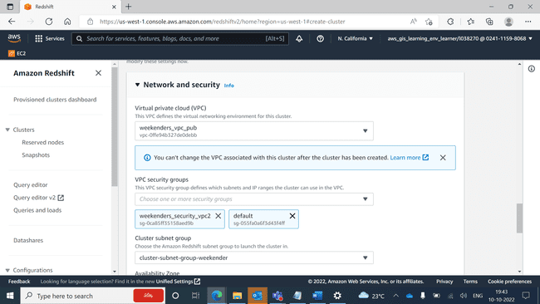

Cluster has been created

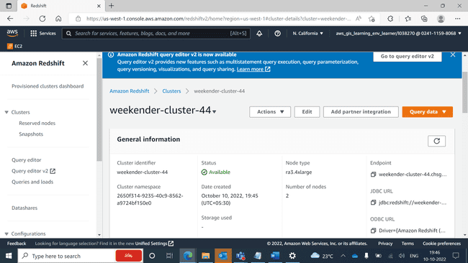

Creating connection

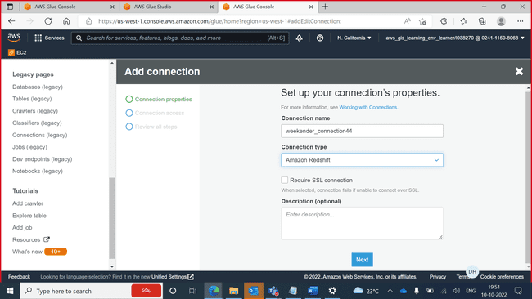

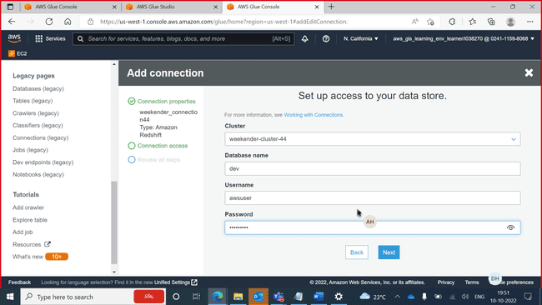

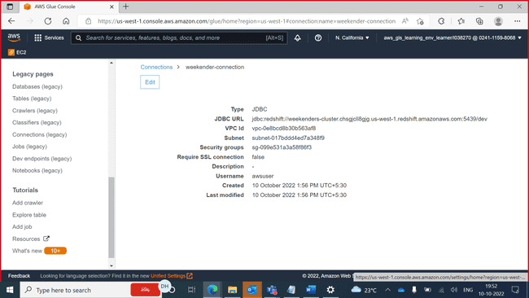

Connected database

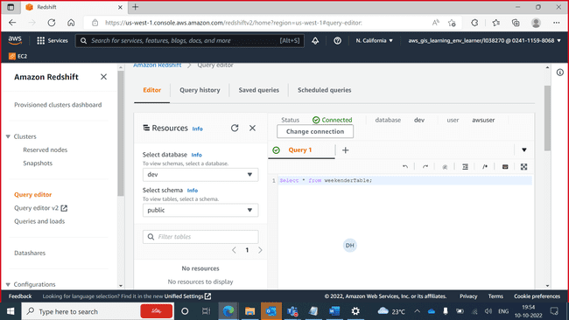

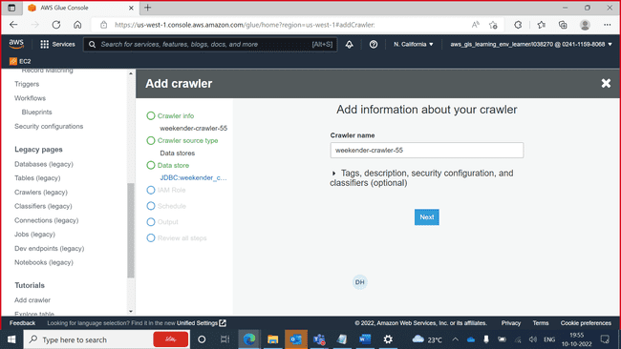

Created new crawler and running it

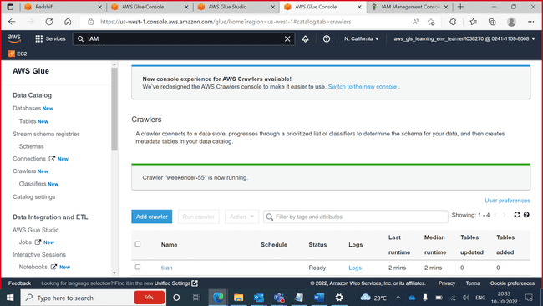

Can see the table

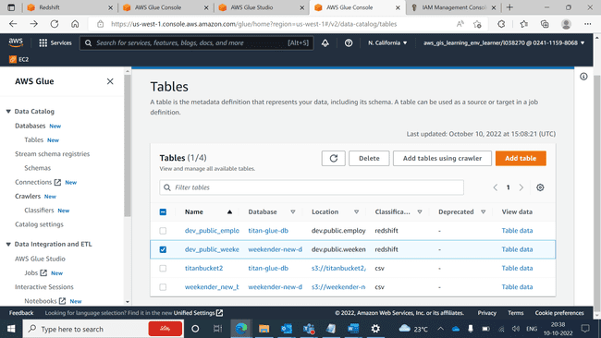

Creating job

